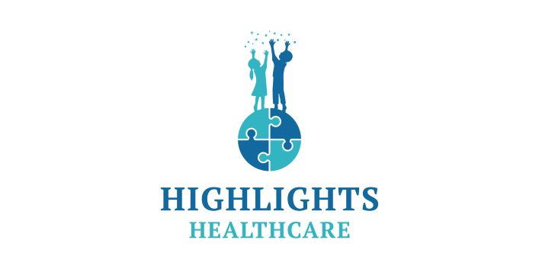
Position Description
Position Title: Board Certified Behavior Analyst | Reports To: Director of Operations
Supervisory Position: Yes | FLSA Status: Exempt
Position Type: Full/Part Time | Department: Clinical

Highlights Healthcare ABA is now hiring Board Certified Behavior Analysts (BCBAs) for our Learning Centers throughout North Carolina. We are offering a $2,500 SIGN ON/RETENTION BONUS plus RELOCATION ASSISTANCE if needed!

Who is Highlights Healthcare?

Highlights Healthcare provides diagnosis and early intervention ABA therapy services to bring meaningful and positive change to children with autism. We specialize in serving young learners and families with Medicaid benefits. We believe every child can achieve great things, and we are guided by family-centered principles that demonstrate dignity and respect.

Our culture fosters manageable caseloads and professional career paths supported by a team of expert leaders. Our operations corporate support center and flagship clinics are in beautiful North Carolina - convenient to the mountains, beaches, professional sports teams, leading universities and world-class dining and entertainment.

Why should you consider a BCBA position with Highlights?

-Monday through Friday schedule – No nights or weekends
-Flexible scheduling with full-time hours
-Clinic and home-based cases available
-Competitive compensation starting at $75,000 annually
-Comprehensive benefits including paid time off (PTO), dental, health, life, and vision insurance, and an employee assistance program
-Professional development assistance including supervision and continuing education (CEUs)

POSITION OVERVIEW

We are currently recruiting clinical staff for our growing clinic and home-based operations throughout North Carolina who are dedicated to effectively providing the best client care possible while working in our supportive clinician-driven environment.

As a Board-Certified Behavior Analyst (BCBA) at Highlights Healthcare, you will:

-Supervise ABA staff for our clients with consideration of dignity and privacy.
-Monitor the effectiveness of skill-building interventions utilizing ABA for children with autism.
-Conduct psychological analyses and diagnostic testing.
-Provide supervision to ABA Behavior Technicians on staff.
-Develop a child-specific behavior plan in accordance with the principles of ABA Therapy.
-Develop and take on projects to improve client service and satisfaction.
-Develop and take on projects to improve employee performance, retention, and satisfaction.
-Develop quality initiatives that will improve referral source satisfaction, measured through volume, surveys, and other reporting methods.
-Maintain knowledge of State and Federal specific laws, Tricare/Governmental programs, Medical Insurance Providers, Medicaid Waiver Programs and ensure compliance with regulations.
-Promote the growth of Highlights Healthcare and assist in the pursuit of new business opportunities.

QUALIFICATIONS

-Master’s Degree from an accredited program in ABA or a related field.
-Current BCBA Certification from the BACB.
-One year of experience in Applied Behavior Analysis (ABA).
-Experience with programming, developing, and implementing intervention programs.
-Must have a reliable car valid Driver’s License, and proof of insurance.
-Demonstrated ability to work independently and produce high-quality results while handling competing priorities.
-Ability to maintain positive learner and family interactions with a high degree of professionalism.
-Proficient knowledge of Microsoft Office (Outlook, Word, Excel) and related computer programs such as Central Reach.
-Ability to obtain and maintain a clear criminal record/fingerprint clearance from the Department of Justice and Federal Bureau of Investigation per HHC and/or program requirements.

Please call Shannon Conroy at 704-658-7095 or click the link below:

https://highlights-healthcare.breezy.hr/

Highlights Healthcare, LLC is an equal opportunity employer and considers all qualified applicants equally without regard to race, color, religion, sex, sexual orientation, gender identity, national origin, veteran status, or Health insurance.

